Prefetching Data:

Implementing Editing Bookings:

Add and Edit Functionality

In the edit-booking.component.ts class

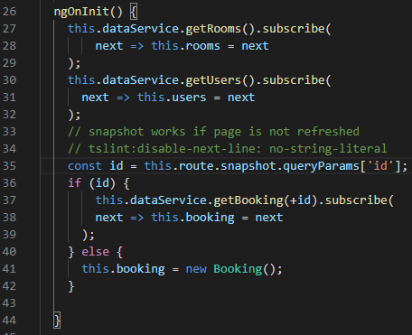

In the Spring API RestBookingsController.java

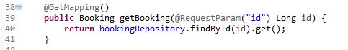

Now, go to the data.service.ts class

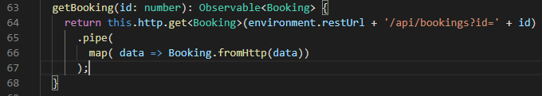

Now, let us look at the UI for Editing a Booking

You need to select the Amend button to edit:

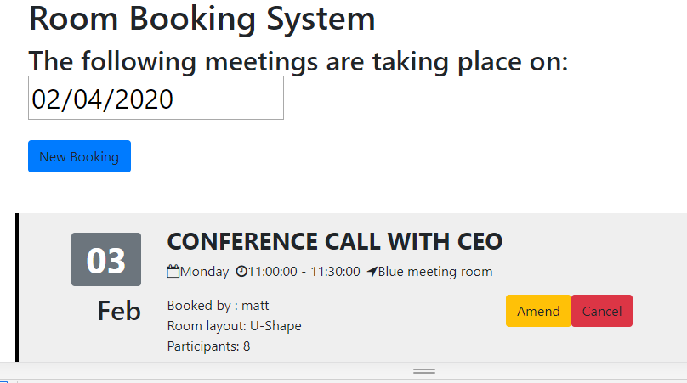

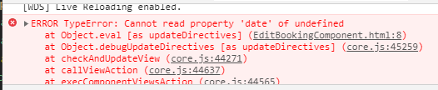

The Room and User are not preloading:

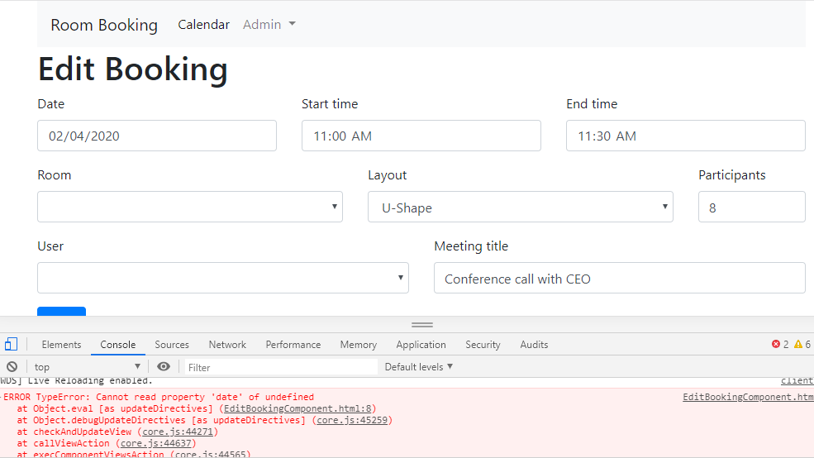

Let us not display the date until it is loaded:

Go into the edit-bookings-component.ts class

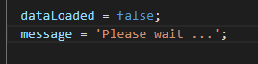

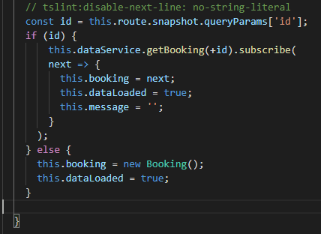

Display the message:

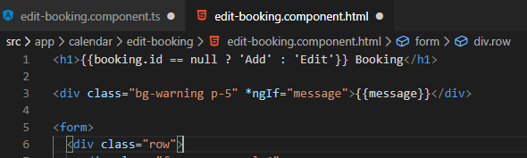

Do not show the form if the data is not loaded



Now let us see if this helps the loading

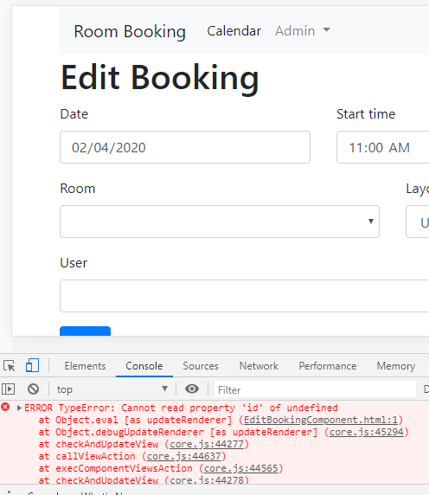

Still got some errors

The Booking data is available before the User and Room

Let us Pre-fetch the data – non production method first

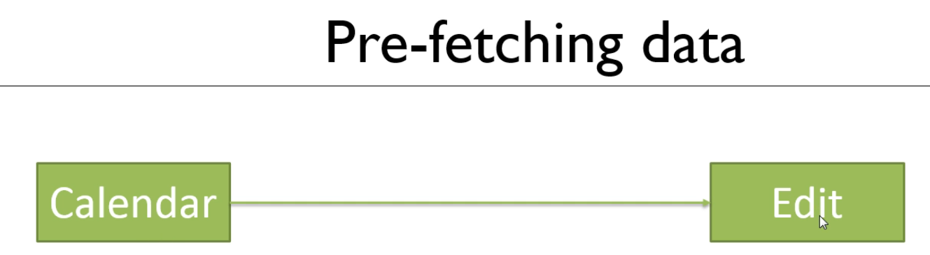

Instead of doing the above we are going to use an intermediate component:

LoadData component

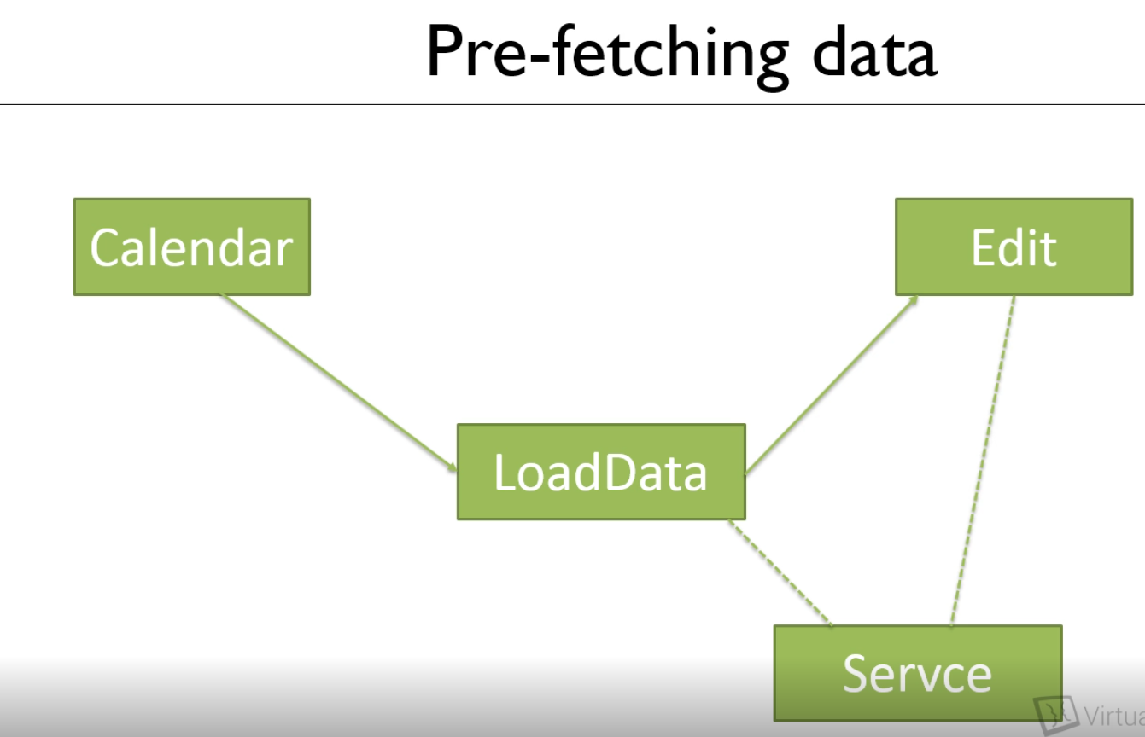

Create a new component and a service

Angular ng, Generate g, Service s EditBookingData <Service> is added automatically





Angular ng, Generate g, Component c under Calendar calendar/EditBookingLoad



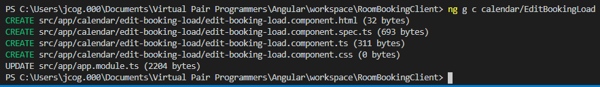

Code the Service first

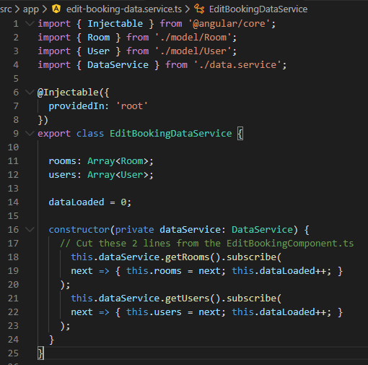

Now the Component

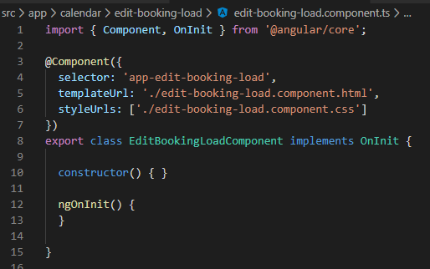

Set up the URL in app-module.ts Add the editBookingLoad url and @NgModule

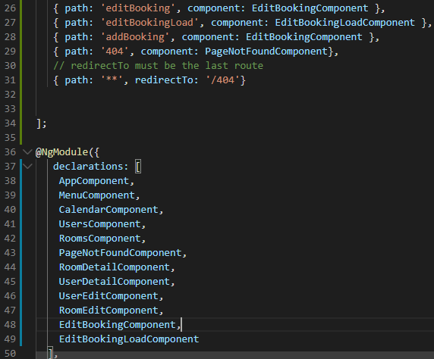

Let us put some html for the Please Wait …



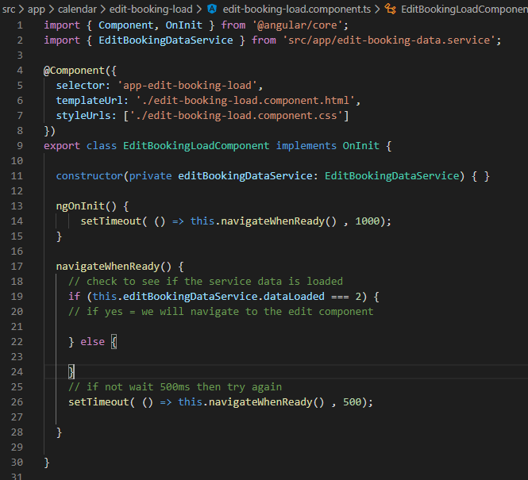

Now we need to make sure we navigate to the editBookingLoad in the calendar.component.ts

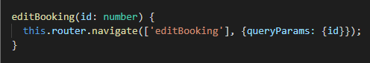

Change to

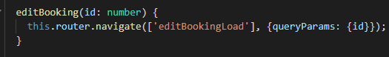

Now copy the route to the load component and add the id and route

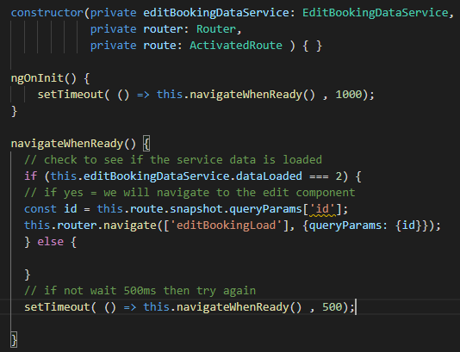

Now fix the setTimeout to the else block

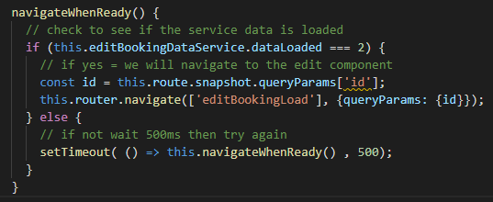

Add the addBooking

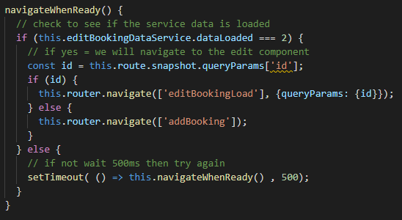

In the Calendar change the addBooking

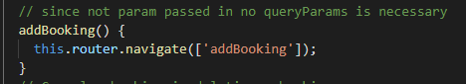

To

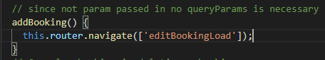

Calendar >> LoadData >> Service

Now finish the last part in edit-booking-component.ts

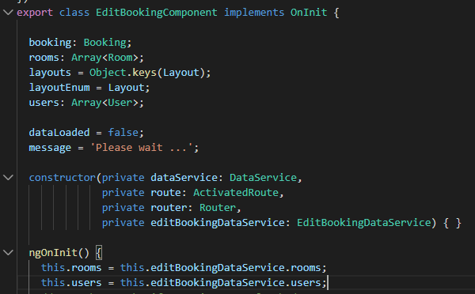

Still have an error

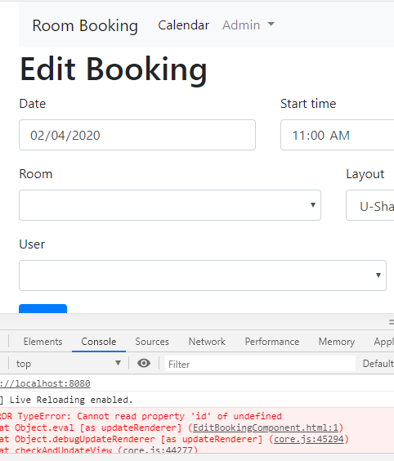

Which room and which user should be assigned as the default:

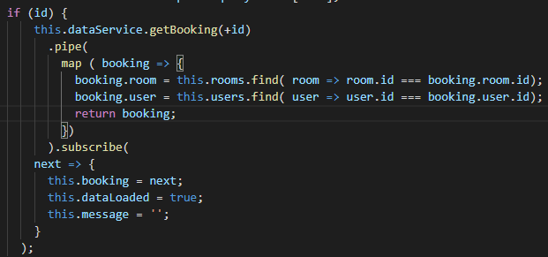

Test this

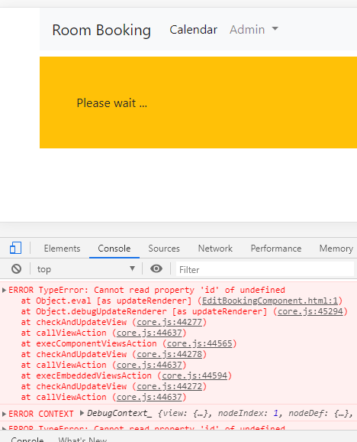

Let us start from the beginning to see if from Amend the room and user prepopulate despite the error

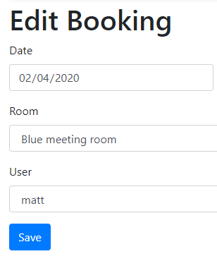

In the edit-booking-component.html file add a null safety



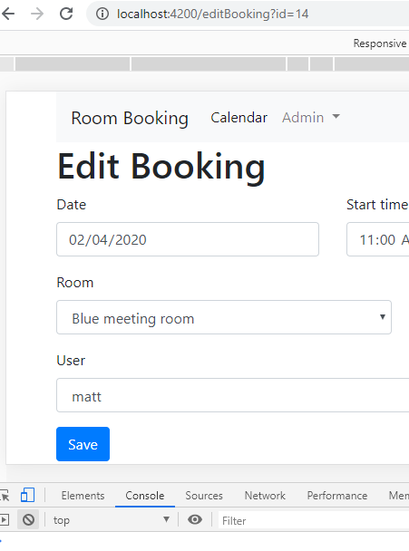

No errors

Using a Resolver:

Production Pre-fetch solution

A resolver resolves an Observer

Create 2 services to replace the solution that we have just created

>ng g s PrefetchRooms



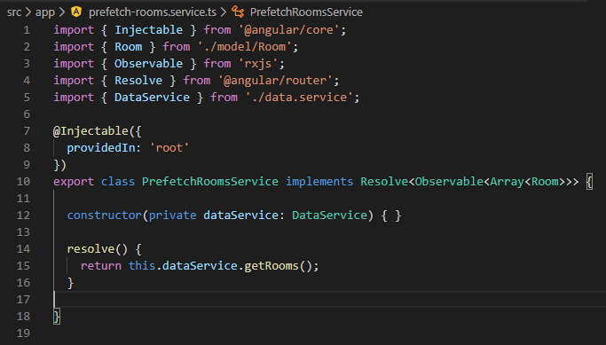

>ng g s PrefetchUsers

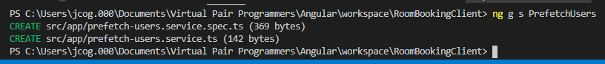

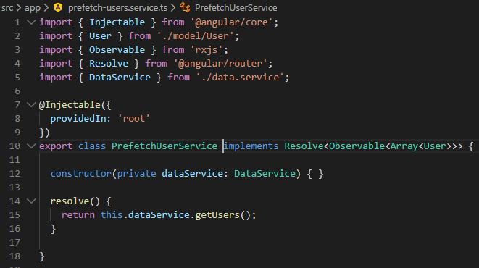

Go to the Calendar-component.ts and replace the editBookingLoad object:

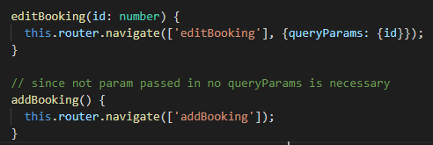

Remove the navigation line from the app.module.ts class for the EditBookingLoadComponent

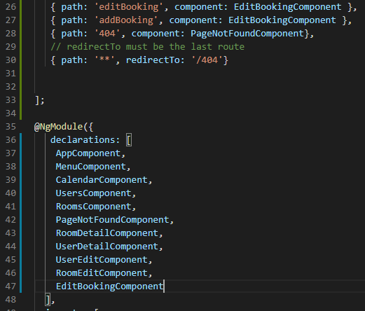

Remove routes and references from the edit-booking-component.ts class

Before:

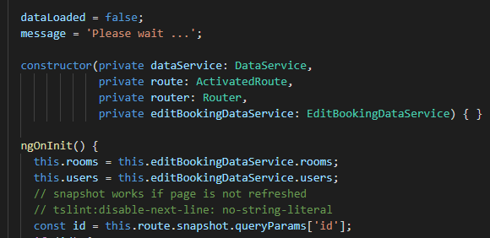

After:

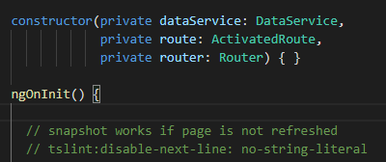

Delete the edit-booking-load components

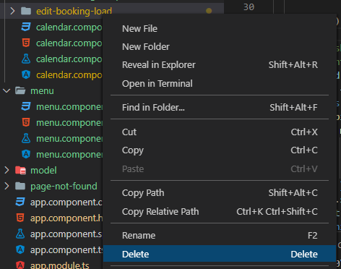

Delete the edit-booking-data.service files

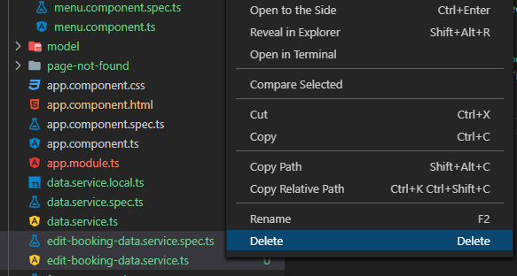

Remove the import from the app.module.ts file



Remove the import from the edit-booking.component.ts file



Now it compiles!

Go to the app-module.ts file to add additional resolving params to the routes

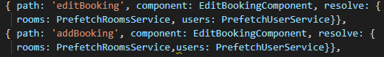

Now, in the edit-booking.component.ts file repopulate the rooms and users from the resolve route:

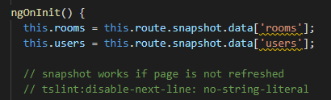

Test this:

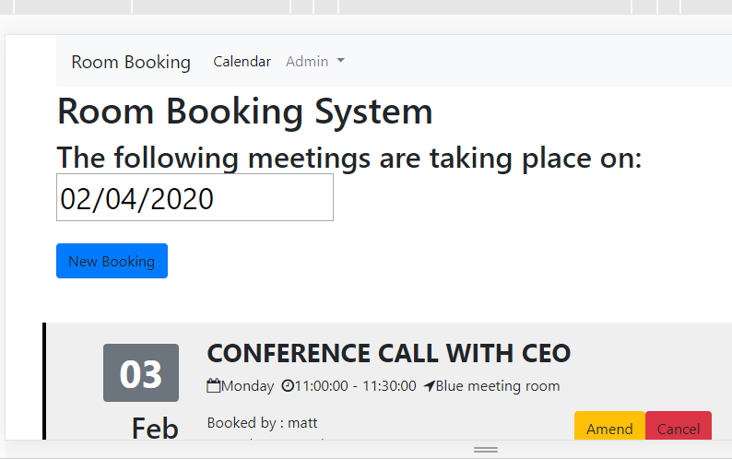

Choose Amend

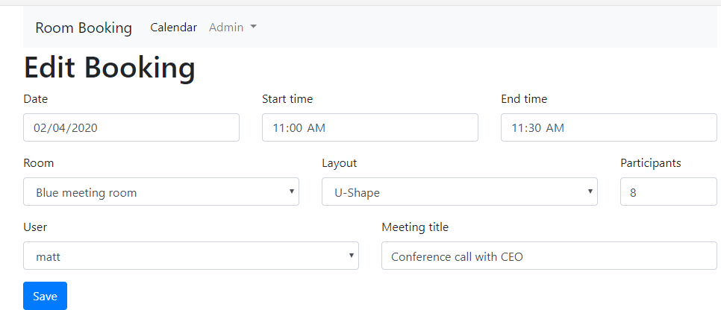

Now try the refresh button, to see if the page reloads correctly



Reloads with no console errors, even with typing into the Meeting title field asdfasdfa

Implement the SAVE button:

We have done save on other pages so no read differences!!!

BookingController.java

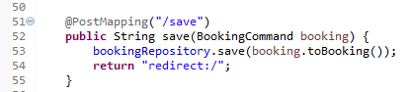

In the data.service.ts file



In the edit-booking.component.ts file

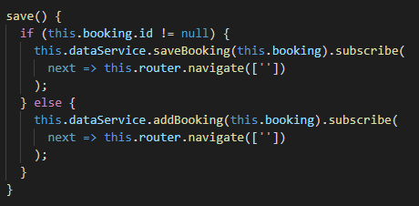

In the edit-booking.component.html file

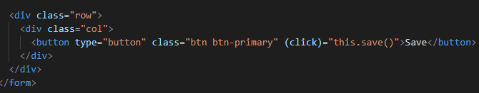

Test it

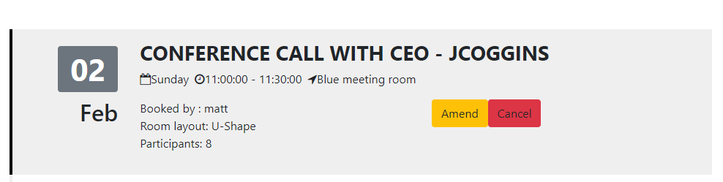

It works